Data Visualizations of EJLPP Books Associated with English Colleges: Highlights from My 2019-2020 Public History Internship
By Lauren Della Piazza Hartke, MA (Georgia Southern University, 2020)

When I started my internship on the Jesuit Libraries Provenance Project, I was acutely aware that I was building on a foundation that was started by another student. Rudy Bond did excellent work on the project and I wanted to continue the momentum that she initiated, but also contribute something uniquely my own to the endeavor. I decided to create data visualizations to demonstrate possible research approaches to our data set, with the goal of applying the findings to my research on the Jesuits’ early activities in England.
Manuel Lima’s book Visual Complexity: Mapping Patterns of Information was very helpful in demonstrating different methods of visually representing data sets and the ways each data set lends itself to different kinds of visualization. I finally settled on a free online site called RAWGraphs (https://rawgraphs.io) which allowed me to upload Excel files, select from over twenty types of graphs, and choose categories of information to prioritize and highlight. A type of graph called an alluvial diagram seemed most suited to the type of information in the database. An alluvial diagram (see below) shows correlation across multiple categories and visualizes which categories are most heavily represented. It also has an element of flow, which appealed to my desire to emphasize the movement of books between print cities and the institutions in which they resided (see Figs. 1 and 2).

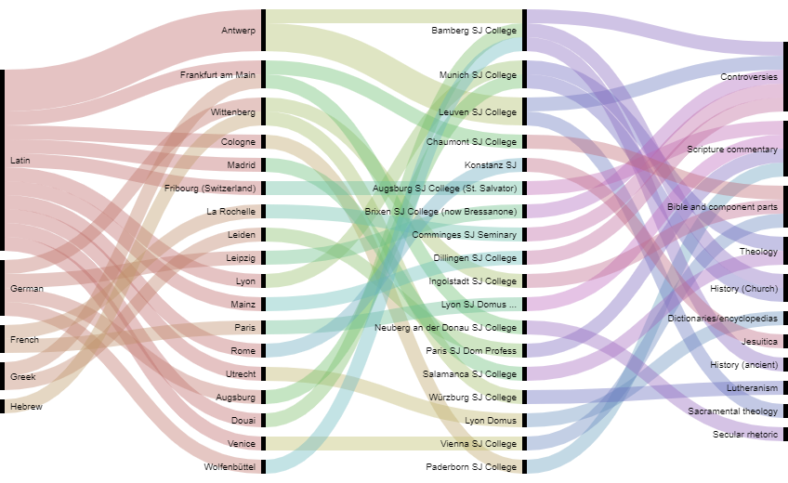
Figure 1. Emory University’s collection, sorted by language, print city, Jesuit institutional provenance, and primary subject. Since the books examined were from the Pitts Theological Library, it makes sense that most of the subjects are theological or doctrinal topics. Since Emory University has been a longtime partner of the EJLPP, I thought it would be fitting to create a graph showcasing their collection.

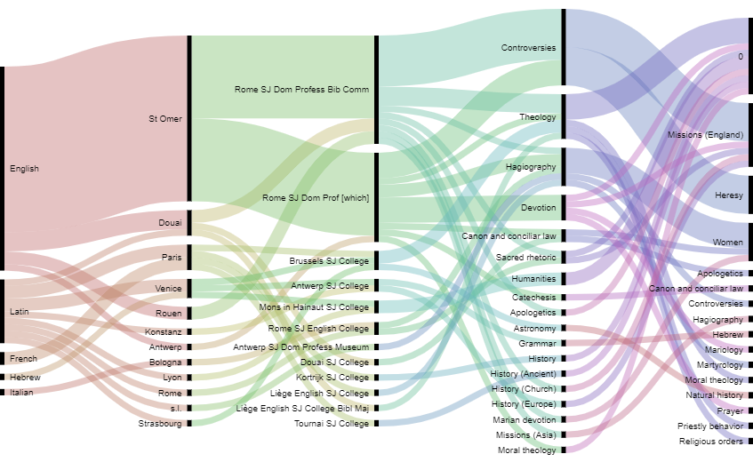
Figure 2. Folger Shakespeare Library’s collection, sorted by language, print city, Jesuit institutional provenance, primary subject and secondary subject. The Folger Library’s collection heavily favors English language books, which is consistent with its origins as a collection of rare Shakespeare folios. It has diversified over the years and now houses a respectable collection of early printed books from England and the European continent.
However, simply dumping information into this tool did not reveal any significant insights (see Fig. 1, below). Since historians are limited in what they can study, they frequently make judgment calls on what to focus on. Similarly, too much information can obscure rather than clarify. My data set of English language books and those associated with English institutions contains over two hundred titles, so the resulting graph was chaotic and complex (see Fig. . Since I was interested in the potential correlation between a book’s print location and destination with a book’s subject, I decided to organize information by language, print city, institutional provenance, and subject. Dr. Comerford and I found ways to combine subject categories to make them more inclusive. For example, we combined “spiritual biography” with “hagiography,” and “heresy,” “controversy,” and “apologetics” under the umbrella term “controversies.” In this way we were able to decrease the number of variables and allow the visualizations to sort the data into meaningful categories.

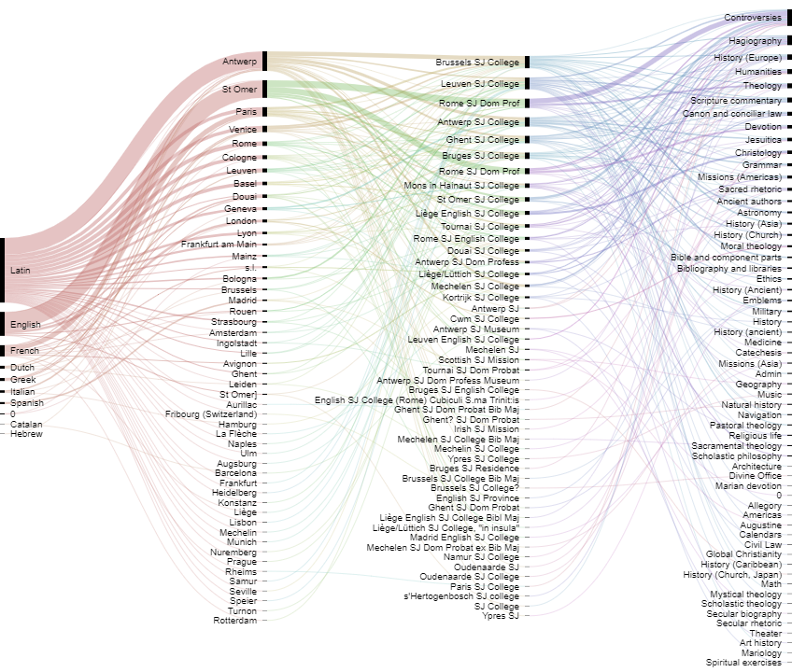
Figure 3. All Belgian and English associated titles, sorted by language, print city, Jesuit Institutional provenance, and primary subject. Clearly, the multitude of variables and visual busyness of the diagram makes it difficult to read and understand. This initial experiment prompted a reassessment of the subject categories and priorities.
By narrowing down the scope to only include English language books and combining subjects, I was able to create a subset of the data that was less confusing and more streamlined (see Fig. 7). This visualization confirmed some of our expectations and also revealed some new insights. Given the tumultuous religious situation in England at this time, we expected to see quite a few titles that pertained to matters of religious and doctrinal controversy. However, we did not see nearly as many books about apologetics as we anticipated. Rather, devotional books about hagiography, theology, and Christology were far more heavily represented. Of these, many were marked as belonging to the Rome Professed House. This institution housed men that had not yet passed their vows to join the Society. These graphs show at a glance a bit of insight into religious life for English Catholic exiles, some of whom were preparing for the priesthood.

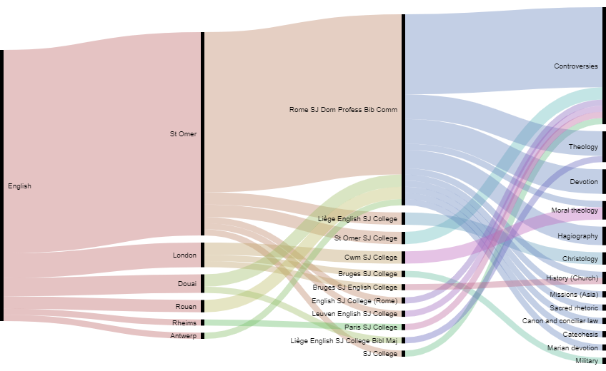
Figure 4. English language books, sorted by language, print city, Jesuit institutional provenance, and primary subject.
These findings were also supported in other primary and secondary source literature. Thomas H. Clancy examines a corpus of spiritual literature in England from 1614-1640 in an article for the journal Recusant History. He calls this time “a rich period for Catholic publishing.” One book widely printed and circulated during this period was The Christian Directory by Robert Persons (the same man who led that first ill-fated Jesuit mission into England). Originally published in 1583, The Christian Directory is a work of devotional literature and is considered Persons’ magnum opus. The book was extremely popular among English Catholics (so much so that Edmund Bunny took it and reworked it for Protestant audiences in 1584). Persons explains the environment that inspired the book in one of his prefaces, saying he was “consideringe the greate want of spirituall bookes in Englande, for the direction of men to pietie and devotion.” He specifically names a lack of pietistic and devotional literature. Concerning controversial books, Persons makes his opinion clear in his marginal note to his preface which reads “Books of controversie, necessarie though not profitable to devotion.” During this period, Jesuits actively engaged in a “battle of the books'' with Protestant contemporaries, publishing defenses of their doctrine and refutations of others’ arguments. Though these debates would appear as trivial minutiae to modern readers, for those who experienced it they were nothing short of fights for the essence of Christian faith itself, with eternal consequences for those involved. Debates frequently became heated, with long inflammatory titles such as The Overthrow of the Protestants pulpit-Babels as well as Purgatories Triumph over Hell (both by John Floyd and found in the EJLPP; see Fig. 8 below). Robert Persons grimly admits the necessity of apologetics and books on controversies, yet looks forward with hope to an end to “infinite contentions of religion” and a time when “each man [will] betake himself to a good and virtuous life.” Thus, at least for Persons, books on religious controversies were a temporary means to an end, that end being the unencumbered circulation of Catholic devotional literature and the free exercise of the Catholic faith in England.
Outside of specific research, these types of data analyzing tools have applications in public history and other humanities fields. Libraries and archives could use them to view the strengths of their collections at a glance. This could also show areas or topics where they may be deficient and promote acquisition of other resources. It is our hope at the EJLPP that these kinds of digital tools will pave the way for more scholars and institutions to use technology to reach a broader audience and promote the free exchange of information and ideas.

Manuel Lima. Visual Complexity: Mapping Patterns of Information (New York: Princeton Architectural Press, 2013).
“History of the Collection,” Folger Shakespeare Library, February 10, 2015, https://www.folger.edu/history-the-collection. (accessed June 11, 2020).
Thomas H. Clancy, “Spiritual Publications of English Jesuits, 1615–1640,” Recusant History 19, no. 4 (1989): 426-446, here 426.
Clancy, “Spiritual Publications of English Jesuits, 1615–1640,” 440.
Robert Persons, The Christian Directory (1582): The First Booke of the Christian Exercise, Appertayning to Resolution, ed. Victor Houliston (Leiden: Brill, 1998), 5; Robert Persons, S.J., Christian Directory: Guiding Men to Eternall Salvation, Devided into Three Bookes. The First Wherof Teacheth How to Make a Good Resolution. The Second, How to Begin Well. The Third, How to Persevere and End Happily. In This Volume Is Onely Contayned the First Booke, Consisting of Two Partes, Wherof the Former Layeth Downe the Motives to Resolution; and the Other Removeth the Impediments: Both of Them Having Byn Lately Reviewed, Corrected, and Not a Little Altered by the Author Himselfe, for the Greater Commodity and Utility of the Reader (St. Omer: English College Press, 1607) https://digitalcommons.georgiasouthern.edu/jesuit-gallery14/ (accessed June 11, 2020) For Bunny version ,see Edmund Bunny and Robert Persons, A Booke of Christian Exercise Appertaining to Resolution, That Is, Shewing How That We Should Resolve Our Selves to Become Christians Indeed: by R.P. Perused, and Accompanied Now with a Treatise Tending to Pacification: by Edm. Bunny. (London: N. Newton, A. Hatfield, and John Wight, 1584).
Persons, The Christian Directory (1582): The First Booke of the Christian Exercise, Appertayning to Resolution, 6. See also Clancy, 441.

